Experiment-2.3
Student Name: Himanshu UID: 20BCS7944 Branch: BE-CSE Section/Group: 905 A
Subject Name: IOT Lab Subject Code: 20CSP-358 Date Of Performance: 20/04/2023 Semester: 6th

Aim: To display data generated by sensor on LCD using Arduino/ Raspberry Pi.

Objectives:
- Learn how to make connections with Arduino board .
- Learn using LCD with Arduino.

Components Required:
Arduino Uno board, LCD display, Jumper wires, Arduino IDE

Circuit Diagram:

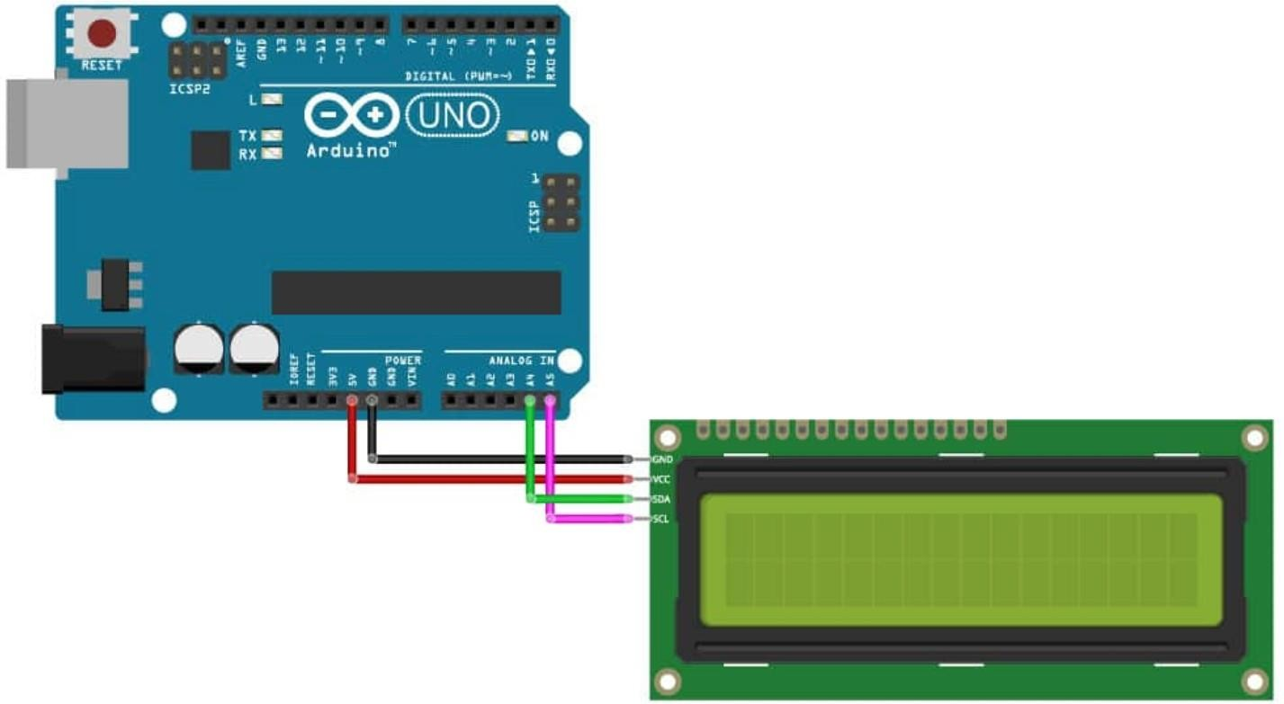
Fig - Circuit Diagram of Connections of LCD with Arduino

Script & Output:
1. (a)Code in Arduino IDE -
#include <LiquidCrystal_I2C.h>
//included the library of I2C LCD LiquidCrystal_I2C lcd(0x27, 16, 2);
//declared the I2C LCD

void setup(){ lcd.init();
//used the built-in function of keypad library function to initialize the LCD
lcd.backlight();
//turn on the backlight of LCD lcd.print("HELLO CU");
// print on the LCD
}
void loop(){
}

(b) Simulation-

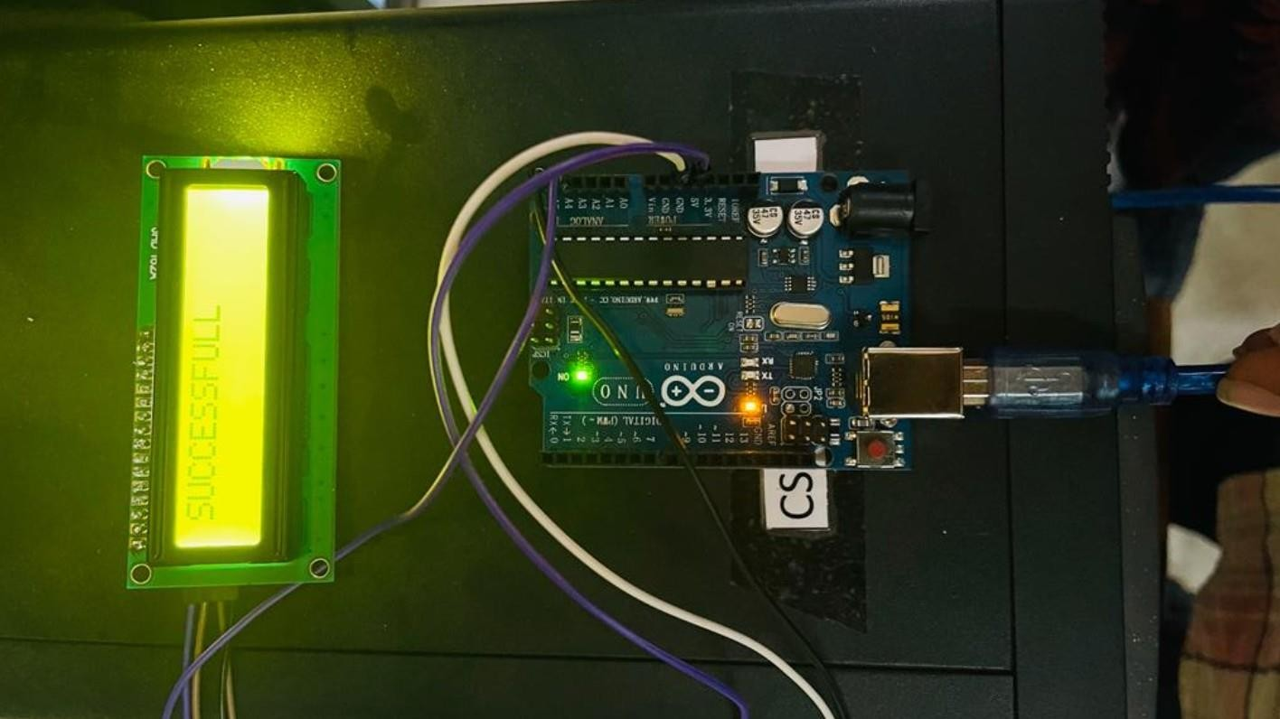
Fig - Final Output with LCD Displaying “SUCCESSFULL”

Result:
1. We see our LCD displaying “SUCCESSFULL”.

Conclusion:
- We learned to use LCD with Arduino.
- We learned to make the connections with Arduino Board.

